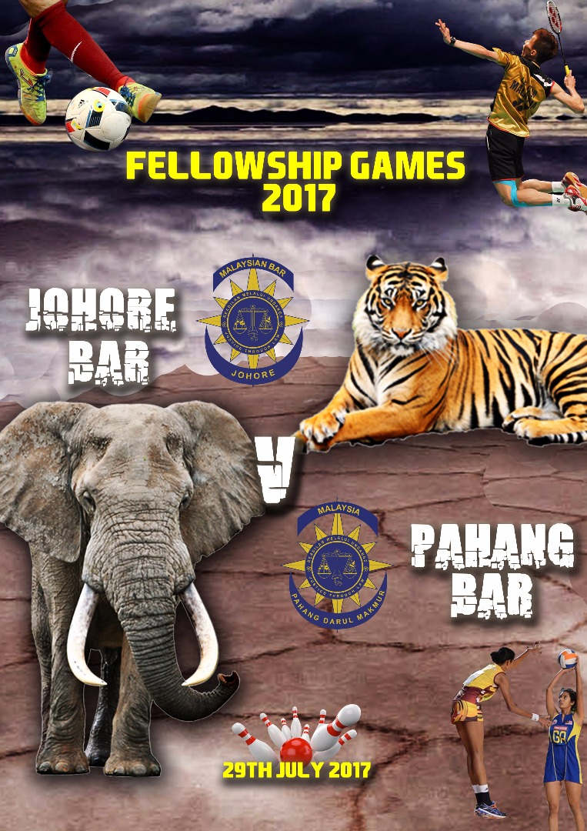

Dear all members of Johore Bar,

The second edition of Johore Bar v Pahang Bar Games will be held on 29th of July 2017 (Saturday).
The utmost purpose of this annual event is to foster greater ties and camaraderie between the Johore Bar and the Pahang Bar.
Fellow members and pupils in chamber may refer the schedule below to join this event. You may also contact respective convenors for any enquiries.
No. | Sports/Event | Venue/Time | Convenor/ Person in Charge
1 | Futsal | Everyday Sports  PTD 32016, Jalan Anggerik 2/4, Taman Anggerik, Johor.  10.00 a.m | Mr Muzammil Hairiri  019-481 0041
2 | Football | Padang Kolej Dato Onn Ja’far UTM  4.00 p.m | Mr Mohamad Salihen  017-788 3825
3 | Netball | KBS Larkin  3.00 p.m | Miss Fatin Nasihah  013-749 1431
4 | Badminton | TBD | Mr Mohan  017-784 4868
5 | Dinner |  | JBC Secretariat

Thank you,
Pride in battle,
KHAIRUL ASRI BIN AHMAD

- Dear secretariat, you may amend accordingly. Thank you.

